CSU’s AUCC Category 2: Advanced Writing
GT Pathways Advanced Writing (CO3)

AUCC and Guaranteed Transfer (GT) Pathways Course (Re)submission Process
- CIM course proposal: Submit through the CIM-Courses website – detailed CIM forms instructions below.
  - Attach the Course Syllabus Template that includes the required CDHE language as outlined below.
  - Attach the CDHE GT Pathways Course Submittal Form & Institution Verification.
  - Submit the course proposal with the attachments through the regular CIM workflow to be reviewed by your college curriculum committee and the University Curriculum Committee (UCC). Once approved by the UCC and Faculty Council, the Provost’s Office will submit the resubmission paperwork to the CDHE.

- Course Syllabus Template: Create a syllabus template for the course that includes the SLOs, Content Criteria, and the required GT Pathways designation statement: The Colorado Commission on Higher Education has approved XXXX #### for inclusion in the Guaranteed Transfer (GT) Pathways program in the GT-XXX category. For transferring students, successful completion with a minimum C‒ grade guarantees transfer and application of credit in this GT Pathways category. For more information on the GT Pathways program, go to https://cdhe.colorado.gov/guaranteed-transfer-gt-pathways-general-education-curriculum

- CDHE GT Pathways Course Submittal Form & Institutional Verification (Link to Submittal Form):
Complete each section (I-IV). In Section IV, explain how your unit will ensure that the required GT Pathways information will be included on each syllabus for every section of the course and how this will be regularly communicated to teaching faculty. Section V ‘Institutional Verification’ will be completed by the Provost’s Office after UCC review.

Additional GT Pathways information is available on the Curriculum & Catalog website: https://curriculum.colostate.edu/aucc. Contact your UCC Representative or the Curriculum & Catalog Unit at curriculum@colostate.edu with questions/concerns about the AUCC and GT Pathways (re)submission process.
CIM COURSE PROPOSAL: The instructions below apply to both EXISTING and NEW AUCC course proposals.
- For the Proposed Changes field at the top of the CIM course proposal, click “Major”. Every field in red outline is required.

- Under the AUCC section, select the appropriate AUCC category.

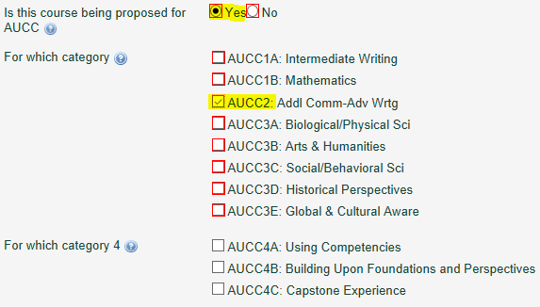

3. Respond to the prompt on the CIM form to provide the rationale/justification for including the course in this AUCC category.

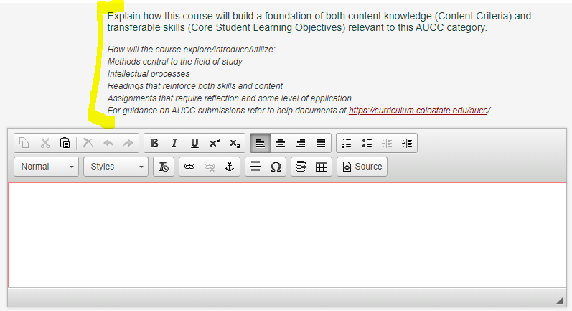
- Select a Guaranteed Transfer (GT) Pathways category that aligns with this AUCC category.

- Use the green ‘Attach Form(s)’ button to attach the CDHE GT Pathways Course Submittal Form & Institution Verification and the Course Syllabus Template that include all required Core Student Learning Outcomes, Course Content, and the required GT Pathways statement.
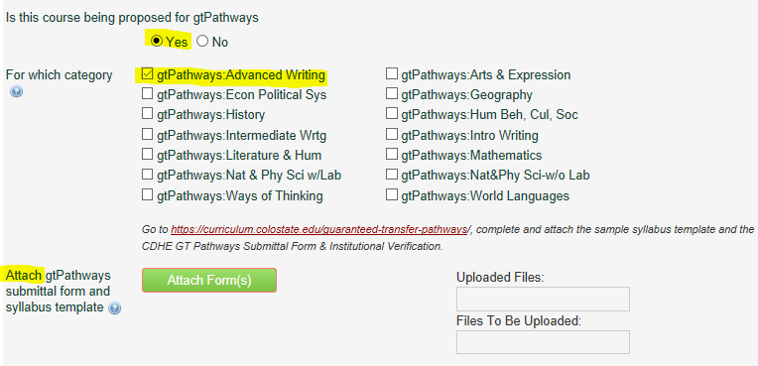
- Under the Course Learning Objectives field, copy and paste the Core Student Learning Outcomes listed from the appropriate chart below verbatim. The Curriculum & Catalog Unit will standardize the formatting on this section, so do not worry if your SLOs are not formatted perfectly.

NOTE: The Course Content grid is no longer a required field on the CIM form. Previously approved content is still viewable for historical purposes, but it is not available to edit.
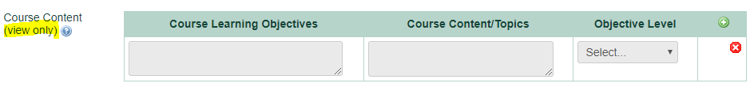

- Complete the Specific Course Topics/Units/Weekly Schedule grid. In the ‘CLO Number’ column, list the Core Student Learning Outcome(s) that will be addressed by the ‘Lecture Content’ and/or the ‘Lab/Recitation/Other Content’ each week. You can list each CLO number separately or you can list multiple CLOs on each row – whatever works best to correspond to the weekly content columns (examples in screenshot below). Click the green “+” button to add additional rows for each week.

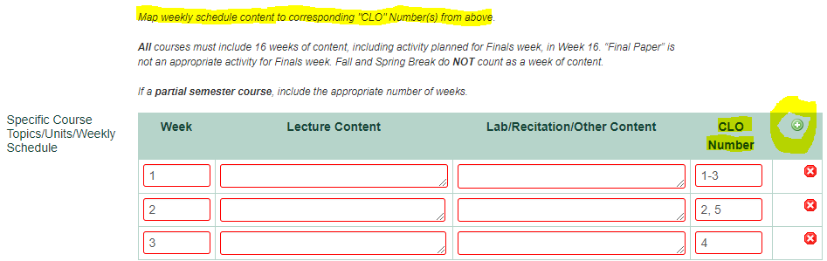

CSU’s AUCC Category 2: Advanced Writing GT Pathways Advanced Writing (CO3)

The following statement must be copied and pasted verbatim into each instructor’s syllabus for every section, every term (replace the text in red with your course subject code & number and the correct GT category): The Colorado Commission on Higher Education has approved XXXX #### for inclusion in the Guaranteed Transfer (GT) Pathways program in the GT-CO3 category. For transferring students, successful completion with a minimum C‒ grade guarantees transfer and application of credit in this GT Pathways category. For more information on the GT Pathways program, go to https://cdhe.colorado.gov/guaranteed-transfer-gt-pathways-general-education-curriculum
Course syllabi: The Content Criteria and Core Student Learning Outcomes below must be copied and pasted verbatim into each instructor’s syllabus for every section, every term.
CIM proposals: Copy/paste the Core Student Learning Outcomes below into the Course Learning Objectives section. Respond to the following prompt in the AUCC justification section, “Explain how this course will build a foundation of both content knowledge (Content Criteria) and transferable skills (Core Student Learning Outcomes) relevant to this AUCC Category. For example, how will the course explore/introduce/utilize methods central to the field of study, intellectual processes, readings that reinforce both skills and content, and/or assignments that require reflection and some level of application.”
AUCC Category | GT Pathways Content Area | Content Criteria  Content Competencies pertain to the knowledge base, methods, concepts, and content-related learning that students should garner from participation in a course. Students should be able to demonstrate acquisition of such content focused learning as a result of participation in courses in each category of the AUCC. | Core Student Learning Outcomes  Core Student Learning Outcomes are transferable skills that students garner in a variety of educational settings and that have wide applicability across fields and in life
Category 2: Advanced Writing | GT-CO3:  Advanced Writing Course | - Extend Rhetorical Knowledge  - Use texts from rhetoric, discourse studies, communication, or related disciplines to extend understanding of rhetorical concepts to the discipline that is the focus of the course.  - Develop sophisticated strategies for critical analysis of disciplinary or specialized discourse.  - Learn more sophisticated ways to communicate knowledge to appropriate audiences.  - Apply reflective strategies to the synthesis, communication, and creation of knowledge.  - Extend Experience in Writing  - Hone recursive strategies for generating ideas, revising, editing, and proofreading for disciplinary or specialized discourse.  - Critique one’s own and other’s work, including the work of professional writers and/or scholars.  - Extend Critical and Creative Thinking  - Reflect on the implications and consequences of context.  - Incorporate alternate, divergent or contradictory perspectives or ideas within one’s own position.  - Extend and complicate the consequences of the stated conclusion.  - Use Sources and Evidence  - Select, evaluate, and synthesize appropriate sources and evidence.  - Use discipline-appropriate criteria to evaluate sources and evidence.  - Extend Application of Composing Conventions  - Select and adapt genre conventions including structure, paragraphing, tone, mechanics, syntax, and style for disciplinary or specialized discourse.  - Use specialized vocabulary, format, and documentation appropriately in more extensive or in-depth writing project. | Written Communication  - Employ Rhetorical Knowledge  - Exhibit a thorough understanding of audience, purpose, genre, and context that is responsive to the situation.  - Develop Content  - Create and develop ideas within the context of the situation and the assigned task(s).  - Apply Genre and Disciplinary Conventions  - Apply formal and informal conventions of writing, including organization, content, presentation, formatting, and stylistic choices, in particular forms and/or fields.  - Use Sources and Evidence  - Critically read, evaluate, apply, and synthesize evidence and/or sources in support of a claim.  - Follow an appropriate documentation system.  - Control Syntax and Mechanics  - Demonstrate proficiency with conventions, including spellings, grammar, mechanics, and word choice appropriate to the writing task.

