CSU’s AUCC Category 1A: Intermediate Writing
GT Pathways Written Communication (CO2)

Note: Utilize this help document for all AUCC and GT Pathways proposals submitted in CIM prior to August 2019.

AUCC and Guaranteed Transfer (GT) Pathways Course (Re)submission Process
- CIM course proposal: Submit through the CIM-Courses website – detailed CIM forms instructions below.
  - Attach the Course Syllabus Template that includes the required CDHE language as outlined below.
  - Attach the CDHE GT Pathways Course Submittal Form & Institution Verification.
  - Submit the course proposal with the attachments through the regular CIM workflow to be reviewed by your college curriculum committee and the University Curriculum Committee (UCC). Once approved by the UCC and Faculty Council, the Provost’s Office will submit the resubmission paperwork to the CDHE.

- Course Syllabus Template: Create a syllabus template for the course that includes the SLOs, Content Criteria, and the required GT Pathways designation statement: The Colorado Commission on Higher Education has approved XXXX #### for inclusion in the Guaranteed Transfer (GT) Pathways program in the GT-CO2 category. For transferring students, successful completion with a minimum C‒ grade guarantees transfer and application of credit in this GT Pathways category. For more information on the GT Pathways program, go to http://highered.colorado.gov/academics/transfers/gtpathways/curriculum.html.

- CDHE GT Pathways Course Submittal Form & Institutional Verification (Link to Submittal Form):
Complete each section (I-IV). In Section IV, explain how your unit will ensure that the required GT Pathways information will be included on each syllabus for every section of the course and how this will be regularly communicated to teaching faculty. Section V ‘Institutional Verification’ will be completed by the Provost’s Office after UCC review.

Additional GT Pathways information is available on the Curriculum & Catalog website: https://curriculum.colostate.edu/aucc. Contact your UCC Representative or the Curriculum & Catalog Unit at curriculum@colostate.edu with questions/concerns about the AUCC and GT Pathways (re)submission process.
CIM COURSE PROPOSAL:
- For the Proposed Changes field at the top of the CIM course proposal, click “Major”. Every field in red outline is required.
- For both EXISTING and NEW AUCC course proposals, under the AUCC section, respond to the prompt listed below rather than the text currently on the CIM form:
Explain how this course will build a foundation of both content knowledge (Content Criteria) and transferable skills (Core Student Learning Outcomes) relevant to this AUCC category. For example, how will the course explore/introduce/utilize methods central to the field of study, intellectual processes, readings that reinforce both skills and content, and/or assignments that require reflection and some level of application.
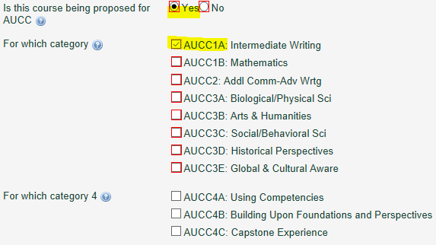
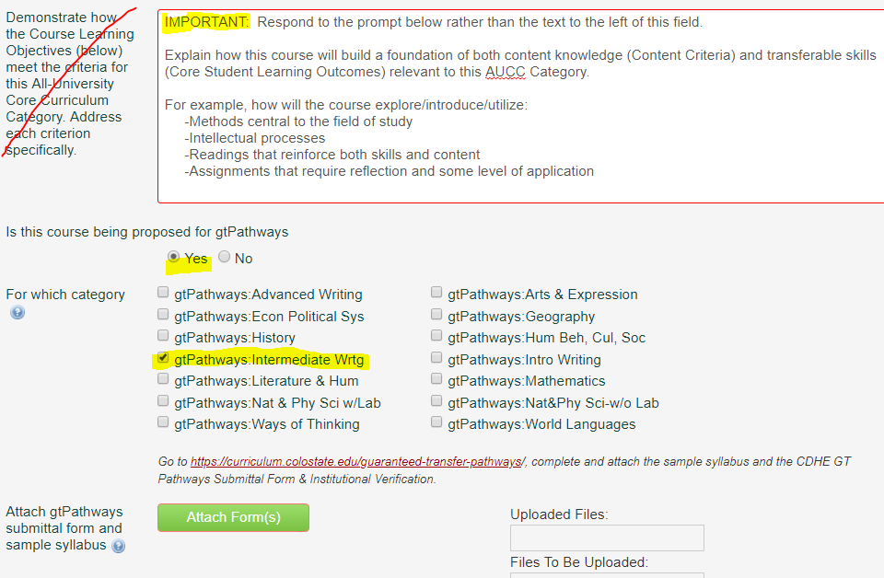

- Under the Course Learning Objectives field, copy and paste the Core Student Learning Outcomes listed in the chart on page 3 of this document verbatim. The formatting on this field will be standardized by the Curriculum & Catalog Unit, so do not worry if your SLOs are not formatted perfectly.

- Complete the Course Content field by listing the appropriate Core Student Learning Outcome number in the first column. You can list each CLO separately or you can list multiple CLOs on each row – whatever works best to correspond to the ‘Course Content/Topics’ column. See CIM Help Bubble for detailed instructions. Click the green “+” button to add additional rows.
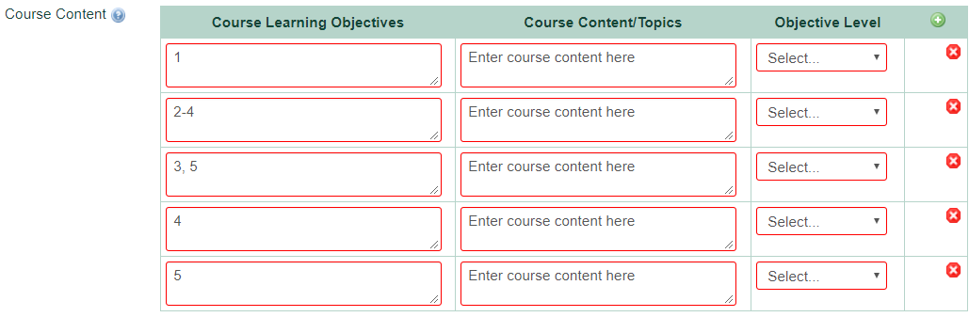

CSU’s AUCC Category 1A: Intermediate Writing GT Pathways Written Communication (CO2)

The following statement must be copied and pasted verbatim into each instructor’s syllabus for every section, every term (replace the text in red with your course subject code & number and the correct GT category): The Colorado Commission on Higher Education has approved XXXX #### for inclusion in the Guaranteed Transfer (GT) Pathways program in the GT-CO2 category. For transferring students, successful completion with a minimum C‒ grade guarantees transfer and application of credit in this GT Pathways category. For more information on the GT Pathways program, go to http://highered.colorado.gov/academics/transfers/gtpathways/curriculum.html.
Course syllabi: The Content Criteria and Core Student Learning Outcomes below must be copied and pasted verbatim into each instructor’s syllabus for every section, every term.
CIM proposals: Copy/paste the Core Student Learning Outcomes below into the Course Learning Objectives section. Respond to the following prompt in the AUCC justification section, “Explain how this course will build a foundation of both content knowledge (Content Criteria) and transferable skills (Core Student Learning Outcomes) relevant to this AUCC Category. For example, how will the course explore/introduce/utilize methods central to the field of study, intellectual processes, readings that reinforce both skills and content, and/or assignments that require reflection and some level of application.”
AUCC Category | GT Pathways Content Area | Content Criteria  Content Competencies pertain to the knowledge base, methods, concepts, and content-related learning that students should garner from participation in a course. Students should be able to demonstrate acquisition of such content focused learning as a result of participation in courses in each category of the AUCC. | Core Student Learning Outcomes  Core Student Learning Outcomes are transferable skills that students garner in a variety of educational settings and that have wide applicability across fields and in life.
1A: Intermediate Writing | GT-CO2:  Intermediate Writing Course | - Deepen Rhetorical Knowledge  - Focus on rhetorical situation, audience, and purpose.  - Use voice, tone, format, and structure appropriately, deepening understanding of relationships between form and content in writing.  - Write and read texts written in several genres, for specified discourse communities. These communities may be professional or disciplinary.  - Practice reflective strategies.  - Deepen Experience in Writing  - Develop recursive strategies for generating ideas, revising, editing, and proofreading for extensive, in-depth, and/or collaborative projects.  - Critique one’s own and other’s work.  - Deepen Critical and Creative Thinking  - Evaluate the relevance of context.  - Synthesize other points of view within one’s own position.  - Reflect on the implications and consequences of the stated conclusion.  - Use Sources and Evidence  - Select and evaluate appropriate sources and evidence.  - Evaluate the relevance of sources to the research question.  - Deepen Application of Composing Conventions  - Apply genre conventions including structure, paragraphing, tone, mechanics, syntax, and style to more extensive or in-depth writing projects.  - Use specialized vocabulary, format, and documentation appropriately. | Written Communication  - Employ Rhetorical Knowledge  - Exhibit a thorough understanding of audience, purpose, genre, and context that is responsive to the situation.  - Develop Content  - Create and develop ideas within the context of the situation and the assigned task(s).  - Apply Genre and Disciplinary Conventions  - Apply formal and informal conventions of writing, including organization, content, presentation, formatting, and stylistic choices, in particular forms and/or fields.  - Use Sources and Evidence  - Critically read, evaluate, apply, and synthesize evidence and/or sources in support of a claim.  - Follow an appropriate documentation system.  - Control Syntax and Mechanics  - Demonstrate proficiency with conventions, including spellings, grammar, mechanics, and word choice appropriate to the writing task.

