CSU’s AUCC Category 3B: Arts & Humanities
GT Pathways Arts & Humanities (AH1, AH2, AH3, AH4)

Note: Utilize this help document for all AUCC and GT Pathways proposals submitted in CIM prior to August 2019.

AUCC and Guaranteed Transfer (GT) Pathways Course (Re)submission Process
- CIM course proposal: Submit through the CIM-Courses website – detailed CIM forms instructions below.
  - Attach the Course Syllabus Template that includes the required CDHE language as outlined below.
  - Attach the CDHE GT Pathways Course Submittal Form & Institution Verification.
  - Submit the course proposal with the attachments through the regular CIM workflow to be reviewed by your college curriculum committee and the University Curriculum Committee (UCC). Once approved by the UCC and Faculty Council, the Provost’s Office will submit the resubmission paperwork to the CDHE.

- Course Syllabus Template: Create a syllabus template for the course that includes the SLOs, Content Criteria, and the required GT Pathways designation statement: The Colorado Commission on Higher Education has approved XXXX #### for inclusion in the Guaranteed Transfer (GT) Pathways program in the GT-XXX category. For transferring students, successful completion with a minimum C‒ grade guarantees transfer and application of credit in this GT Pathways category. For more information on the GT Pathways program, go to http://highered.colorado.gov/academics/transfers/gtpathways/curriculum.html.

- CDHE GT Pathways Course Submittal Form & Institutional Verification – links to submittal forms:
GT-AH1 - Arts & Expression
GT-AH2 - Literature & Humanities
GT-AH3 - Ways of Thinking
GT-AH4 - World Languages
Complete each section (I-IV). In Section IV, explain how your unit will ensure that the required GT Pathways information will be included on each syllabus for every section of the course and how this will be regularly communicated to teaching faculty. Section V ‘Institutional Verification’ will be completed by the Provost’s Office after UCC review.

Additional GT Pathways information is available on the Curriculum & Catalog website: https://curriculum.colostate.edu/aucc. Contact your UCC Representative or the Curriculum & Catalog Unit at curriculum@colostate.edu with questions/concerns about the AUCC and GT Pathways (re)submission process.
CIM COURSE PROPOSAL:
- For the Proposed Changes field at the top of the CIM course proposal, click “Major”. Every field in red outline is required.
- For both EXISTING and NEW AUCC course proposals, under the AUCC section, respond to the prompt listed below rather than the text currently on the CIM form:
Explain how this course will build a foundation of both content knowledge (Content Criteria) and transferable skills (Core Student Learning Outcomes) relevant to this AUCC category. For example, how will the course explore/introduce/utilize methods central to the field of study, intellectual processes, readings that reinforce both skills and content, and/or assignments that require reflection and some level of application.
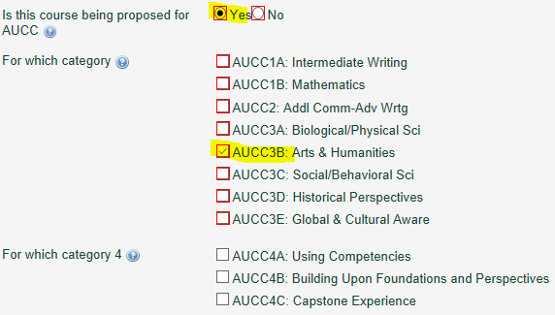

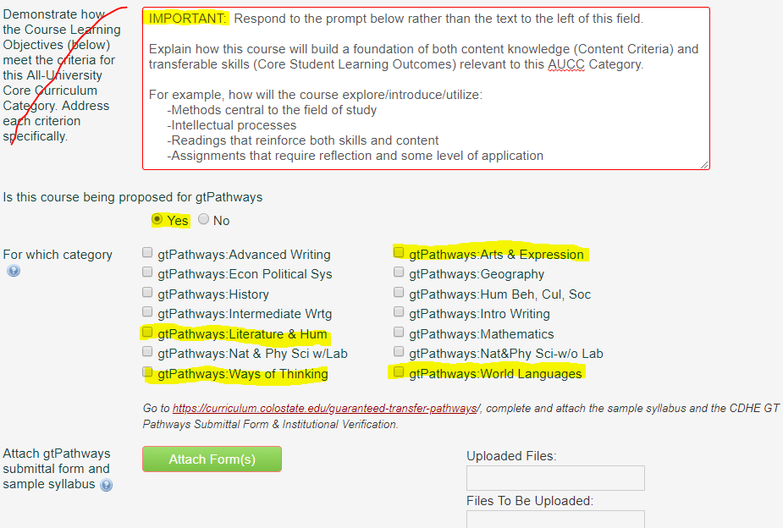

- Under the Course Learning Objectives field, copy and paste the Core Student Learning Outcomes listed in the appropriate chart below verbatim. The Curriculum & Catalog Unit will standardize the formatting on this section, so do not worry if your SLOs are not formatted perfectly.

- Complete the Course Content field by listing the appropriate Core Student Learning Outcome number in the first column. You can list each CLO separately or you can list multiple CLOs on each row – whatever works best to correspond to the ‘Course Content/Topics’ column. See CIM Help Bubble for detailed instructions. Click the green “+” button to add additional rows.
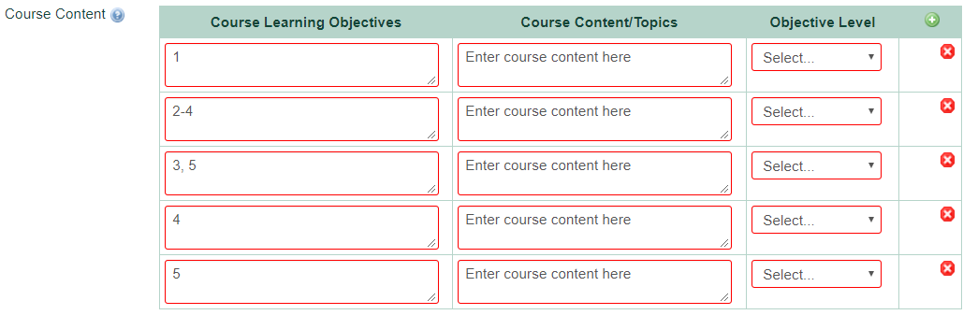

CSU’s AUCC Category 3B: Arts & Humanities GT Pathways Arts & Humanities (AH1, AH2, AH3, AH4)

Courses in this category should provide high impact practices such as writing, collaborative learning, community/civic engagement, or research as relevant to the field.
Courses must base at least 25% of the final grade on writing, a portion of which must be written outside of class. Writing activities may range from brief in-class reflective writing to multi-draft revised papers. Students learn and retain knowledge when they write, reflect upon what they are learning, and engage in revision processes that utilize feedback.

The following statement must be copied and pasted verbatim into each instructor’s syllabus for every section, every term (replace the text in red with your course subject code & number and the correct GT category): The Colorado Commission on Higher Education has approved XXXX #### for inclusion in the Guaranteed Transfer (GT) Pathways program in the GT-XXX category. For transferring students, successful completion with a minimum C‒ grade guarantees transfer and application of credit in this GT Pathways category. For more information on the GT Pathways program, go to http://highered.colorado.gov/academics/transfers/gtpathways/curriculum.html.

Course syllabi: The Content Criteria and Core Student Learning Outcomes below must be copied and pasted verbatim into each instructor’s syllabus for every section, every term.
CIM proposals: Copy/paste the Core Student Learning Outcomes below into the Course Learning Objectives section. Respond to the following prompt in the AUCC justification section, “Explain how this course will build a foundation of both content knowledge (Content Criteria) and transferable skills (Core Student Learning Outcomes) relevant to this AUCC Category. For example, how will the course explore/introduce/utilize methods central to the field of study, intellectual processes, readings that reinforce both skills and content, and/or assignments that require reflection and some level of application.”
AUCC Category |  | GT Pathways Content Area |  | Content Criteria  Content Competencies pertain to the knowledge base, methods, concepts, and content-related learning that students should garner from participation in a course. Students should be able to demonstrate acquisition of such content focused learning as a result of participation in courses in each category of the AUCC. | Core Student Learning Outcomes  Core Student Learning Outcomes are transferable skills that students garner in a variety of educational settings and that have wide applicability across fields and in life.
3B:  Arts & Humanities |  | GT-AH1:  Arts & Expression |  |  | Creative Thinking  - Embrace Contradictions:  - Incorporate alternate, divergent, or contradictory perspectives or ideas within the context of the discipline and the shape of the work.  Critical Thinking  - Utilize Context:  - Evaluate the relevance of context when presenting a position.  - Identify assumptions.  - Analyze one’s own and others’ assumptions.  - Understand Implications and Make Conclusions:  - Establish a conclusion that is tied to the range of information presented.  - Reflect on implications and consequences of stated conclusion.  Diversity & Global Learning  - Build Self-Awareness:  - Demonstrate how their own attitudes, behaviors, or beliefs compare or relate to those of other individuals, groups, communities, or cultures.  - Examine Perspectives:  - Examine diverse perspectives when investigating social and behavioral topics within natural or human systems.  Written/Oral Communication  - Develop Content and Message:  - Create and develop ideas within the context of the situation and the assigned task(s).  - Use Sources and Evidence:  - Critically read, evaluate, apply, and synthesize evidence and/or sources in support of a claim.  8) Use language appropriate to the audience
Respond analytically and critically to works of artistic expression, by addressing all of the following:
- Describe the basic elements and their effects on meaning in a work of art.
- Relate the effects of geography, economics, politics, religion, philosophy, and science on the values of a culture and the stylistic features of its arts.
- Determine how a work reflects or rejects the major values or concerns of a historical era or culture.
- Interpret themes or major concepts.
- Effectively use appropriate competencies in the study of the arts and humanities, including competencies related to the creative process.
AUCC Category | GT Pathways Content Area |  | Content Criteria  Content Competencies pertain to the knowledge base, methods, concepts, and content-related learning that students should garner from participation in a course. Students should be able to demonstrate acquisition of such content focused learning as a result of participation in courses in each category of the AUCC. |  |  | Core Student Learning Outcomes  Core Student Learning Outcomes are transferable skills that students garner in a variety of educational settings and that have wide applicability across fields and in life.
3B:  Arts & Humanities | GT-AH2:  Literature & Humanities |  | Respond analytically and critically to literary or media works, by addressing all of the following:  - Specific era(s)  - Specific culture(s)  - Themes or major concepts  - Attitudes and values |  |  | Critical Thinking  - Utilize Context:  - Evaluate the relevance of context when presenting a position.  - Identify assumptions.  - Analyze one’s own and others’ assumptions.  - Understand Implications and Make Conclusions:  a) Establish a conclusion that is tied to the range of information presented.  b) Reflect on implications and consequences of stated conclusion.  Diversity & Global Learning  - Build Self-Awareness:  - Demonstrate how their own attitudes, behaviors, or beliefs compare or relate to those of other individuals, groups, communities, or cultures.  - Examine Perspectives:  - Examine diverse perspectives when investigating social and behavioral topics within natural or human systems.  Written/Oral Communication  - Develop Content and Message:  - Create and develop ideas within the context of the situation and the assigned task(s).  - Use Sources and Evidence:  - Critically read, evaluate, apply, and synthesize evidence and/or sources in support of a claim.  7) Use language appropriate to the audience

AUCC Category | GT Pathways Content Area | Content Criteria  Content Competencies pertain to the knowledge base, methods, concepts, and content-related learning that students should garner from participation in a course. Students should be able to demonstrate acquisition of such content focused learning as a result of participation in courses in each category of the AUCC. | Core Student Learning Outcomes  Core Student Learning Outcomes are transferable skills that students garner in a variety of educational settings and that have wide applicability across fields and in life.
3B:  Arts & Humanities | GT-AH3:  Ways of Thinking | Respond analytically and critically to ways of thinking, by addressing one or more of the following:  - Logic  - Ethics  - The different questions dealt with by leading philosophers and/or theologians and their positions on those questions | Critical Thinking  - Explain an Issue:  - Use information to describe a problem or issue and/or articulate a question related to the topic.  - Utilize Context:  - Evaluate the relevance of context when presenting a position.  - Identify assumptions.  - Analyze one’s own and others’ assumptions.  - Understand Implications and Make Conclusions:  - Establish a conclusion that is tied to the range of information presented.  - Reflect on implications and consequences of stated conclusion.  Diversity & Global Learning  - Build Self-Awareness:  - Demonstrate how their own attitudes, behaviors, or beliefs compare or relate to those of other individuals, groups, communities, or cultures.  - Examine Perspectives:  - Examine diverse perspectives when investigating social and behavioral topics within natural or human systems.  Written/Oral Communication  - Develop Content and Message:  - Create and develop ideas within the context of the situation and the assigned task(s).  - Use Sources and Evidence:  - Critically read, evaluate, apply, and synthesize evidence and/or sources in support of a claim.  8) Use language appropriate to the audience

AUCC Category | GT Pathways Content Area | Content Criteria  Content Competencies pertain to the knowledge base, methods, concepts, and content-related learning that students should garner from participation in a course. Students should be able to demonstrate acquisition of such content focused learning as a result of participation in courses in each category of the AUCC. | Core Student Learning Outcomes  Core Student Learning Outcomes are transferable skills that students garner in a variety of educational settings and that have wide applicability across fields and in life.
3B:  Arts & Humanities | GT-AH4:  World Languages | Develop an ability to communicate in, and understand, a language other than spoken and written English. Students should be able to:  - Acquire intermediate skills in speaking, aural comprehension, reading, and writing in a language other than English, or  - Acquire intermediate skills in American Sign Language. | Diversity & Global Learning  - Build Self-Awareness:  - Demonstrate how their own attitudes, behaviors, or beliefs compare or relate to those of other individuals, groups, communities, or cultures.  - Examine Perspectives:  - Examine diverse perspectives when investigating social and behavioral topics within natural or human systems.  Written/Oral Communication  - Develop Content and Message:  - Create and develop ideas within the context of the situation and the assigned task(s).  - Use Sources and Evidence:  - Critically read, evaluate, apply, and synthesize evidence and/or sources in support of a claim.  5) Use language appropriate to the audience  - Execute Delivery:  - Demonstrate performance skills (posture, gesture, eye contact, and vocal expressiveness) to share content with/present content to a particular audience for a specific occasion and purpose.

