CSU’s AUCC Category 3A: Biological & Physical Sciences
GT Pathways Natural & Physical Sciences (SC1, SC2)

AUCC and Guaranteed Transfer (GT) Pathways Course (Re)submission Process
- CIM course proposal: Submit through the CIM-Courses website – detailed CIM forms instructions below.
  - Attach the Course Syllabus Template that includes the required CDHE language as outlined below.
  - Attach the CDHE GT Pathways Course Submittal Form & Institution Verification.
  - Submit the course proposal with the attachments through the regular CIM workflow to be reviewed by your college curriculum committee and the University Curriculum Committee (UCC). Once approved by the UCC and Faculty Council, the Provost’s Office will submit the resubmission paperwork to the CDHE.

- Course Syllabus Template: Create a syllabus template for the course that includes the SLOs, Content Criteria, and the required GT Pathways designation statement: The Colorado Commission on Higher Education has approved XXXX #### for inclusion in the Guaranteed Transfer (GT) Pathways program in the GT-XXX category. For transferring students, successful completion with a minimum C‒ grade guarantees transfer and application of credit in this GT Pathways category. For more information on the GT Pathways program, go to https://cdhe.colorado.gov/guaranteed-transfer-gt-pathways-general-education-curriculum

- CDHE GT Pathways Course Submittal Form & Institutional Verification – links to submittal forms:
GT-SC1 – Course with Required Laboratory
GT-SC2 – Lecture Course without Required Laboratory
Complete each section (I-IV). In Section IV, explain how your unit will ensure that the required GT Pathways information will be included on each syllabus for every section of the course and how this will be regularly communicated to teaching faculty. Section V ‘Institutional Verification’ will be completed by the Provost’s Office after UCC review.

Additional GT Pathways information is available on the Curriculum & Catalog website: https://curriculum.colostate.edu/aucc. Contact your UCC Representative or the Curriculum & Catalog Unit at curriculum@colostate.edu with questions/concerns about the AUCC and GT Pathways (re)submission process.
CIM COURSE PROPOSAL: The instructions below apply to both EXISTING and NEW AUCC course proposals.
- For the Proposed Changes field at the top of the CIM course proposal, click “Major”. Every field in red outline is required.

- Under the AUCC section, select the appropriate AUCC category.

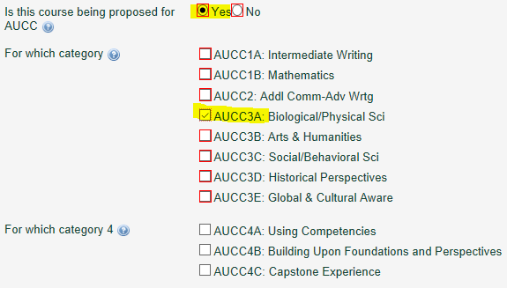

3. Respond to the prompt on the CIM form to provide the rationale/justification for including the course in this AUCC category.
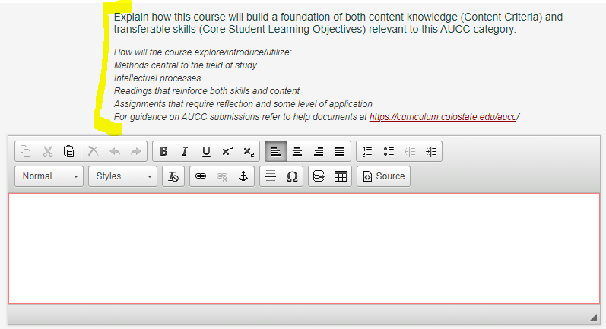
- Select a Guaranteed Transfer (GT) Pathways category that aligns with this AUCC category.

- Use the green ‘Attach Form(s)’ button to attach the CDHE GT Pathways Course Submittal Form & Institution Verification and the Course Syllabus Template that include all required Core Student Learning Outcomes, Course Content, and the required GT Pathways statement.
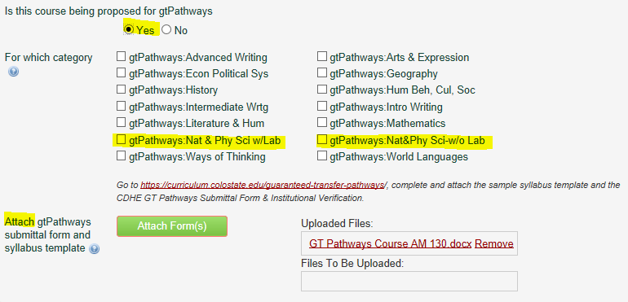

- Under the Course Learning Objectives field, copy and paste the Core Student Learning Outcomes listed from the appropriate chart below verbatim. The Curriculum & Catalog Unit will standardize the formatting on this section, so do not worry if your SLOs are not formatted perfectly.

NOTE: The Course Content grid is no longer a required field on the CIM form. Previously approved content is still viewable for historical purposes, but it is not available to edit.
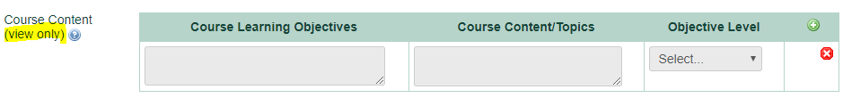

- Complete the Specific Course Topics/Units/Weekly Schedule grid. In the ‘CLO Number’ column, list the Core Student Learning Outcome(s) that will be addressed by the ‘Lecture Content’ and/or the ‘Lab/Recitation/Other Content’ each week. You can list each CLO number separately or you can list multiple CLOs on each row – whatever works best to correspond to the weekly content columns (examples in screenshot below). Click the green “+” button to add additional rows for each week.
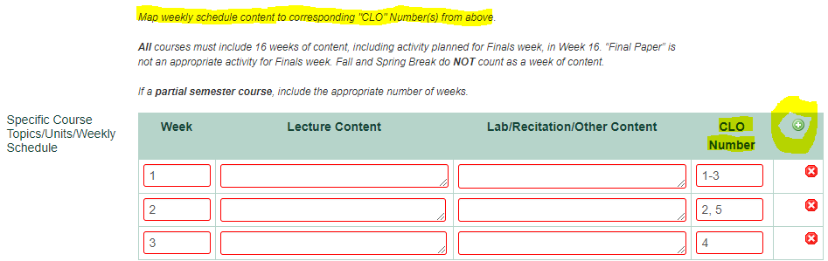

CSU’s AUCC Category 3A: Biological & Physical Sciences GT Pathways Natural & Physical Sciences (SC1, SC2)

Courses in this category should provide high impact practices such as writing, collaborative learning, community/civic engagement, or research as relevant to the field.
The following statement must be copied and pasted verbatim into each instructor’s syllabus for every section, every term (replace the text in red with your course subject code & number and the correct GT category): The Colorado Commission on Higher Education has approved XXXX #### for inclusion in the Guaranteed Transfer (GT) Pathways program in the GT-XXX category. For transferring students, successful completion with a minimum C‒ grade guarantees transfer and application of credit in this GT Pathways category. For more information on the GT Pathways program, go to https://cdhe.colorado.gov/guaranteed-transfer-gt-pathways-general-education-curriculum
Course syllabi: The Content Criteria and Core Student Learning Outcomes below must be copied and pasted verbatim into each instructor’s syllabus for every section, every term.
CIM proposals: Copy/paste the Core Student Learning Outcomes below into the Course Learning Objectives section. Respond to the following prompt in the AUCC justification section, “Explain how this course will build a foundation of both content knowledge (Content Criteria) and transferable skills (Core Student Learning Outcomes) relevant to this AUCC Category. For example, how will the course explore/introduce/utilize methods central to the field of study, intellectual processes, readings that reinforce both skills and content, and/or assignments that require reflection and some level of application.”
AUCC Category | GT Pathways Content Area | Content Criteria  Content Competencies pertain to the knowledge base, methods, concepts, and content-related learning that students should garner from participation in a course. Students should be able to demonstrate acquisition of such content-focused learning as a result of participation in courses in each category of the AUCC. | Core Student Learning Outcomes  Core Student Learning Outcomes are transferable skills that students garner in a variety of educational settings and that have wide applicability across fields and in life.
3A:  Biological & Physical Sciences | GT-SC1:  Natural & Physical Sciences with Required Lab | The lecture content of a science course:  - Develop foundational knowledge in specific field(s) of science.  - Develop an understanding of the nature and process of science.  - Demonstrate the ability to use scientific methodologies.  - Examine quantitative approaches to study natural phenomena.  - Develop concepts of accuracy, precision, and the role of repeatability in the acquisition of scientific knowledge.  - Develop connections between the specific subject matter being taught and other areas of scientific endeavor or human activity.  The laboratory (either a combined lecture and laboratory, or a separate laboratory tied to a science lecture course) content of a science course:  - Perform hands-on activities with demonstration and simulation components playing a secondary role.  - Engage in inquiry-based activities.  - Demonstrate the ability to use the scientific method.  - Obtain and interpret data, and communicate the results of inquiry.  - Demonstrate proper technique and safe practices. | Inquiry & Analysis  - Select or Develop a Design Process  - Select or develop elements of the methodology or theoretical framework to solve problems in a given discipline.  - Analyze and Interpret Evidence  - Examine evidence to identify patterns, differences, similarities, limitations, and/or implications related to the focus.  - Utilize multiple representations to interpret the data.  - Draw Conclusions  - State a conclusion based on findings.  Quantitative Literacy  - Interpret Information  - Explain information presented in mathematical forms (e.g., equations, graphs, diagrams, tables, words).  - Represent Information  - Convert information into and between various mathematical forms (e.g., equations, graphs, diagrams, tables, words).
GT-SC2:
Natural & Physical Sciences without Required Lab

